Subject: Software Requirements
Title: Progress Test 2
Content: Chapter 5,6,7,8
Time: 30’
Number of question: 35/52

QN=1 | Which of the following activities should NOT be done in the phase “Defect evaluation at review meetings” of “Requirements inspection & review process”?
a. | The defects found by each inspector are collected and discussed by the meeting participants
b. | The meeting participants keep only defects on which all agree
c. | Each inspector reads the RD or part of it individually to look for defects.
d. | The team documents the conclusions in an inspection report
e.
f.
ANS: | C
PTS: | 1
CHAPTER: | 5
MIX CHOICES: | YES

QN=2 | Requirements Inspection process uses __________ guidelines to make it more effective in finding defects.
a. | WHY-WHAT-WHO
b. | WHY-WHAT-WHO-HOW
c. | WHAT-WHO-WHEN-WHERE
d. | WHY-WHAT-WHO-WHERE
e.
f.
ANS: | C
PTS: | 1
CHAPTER: | 5
MIX CHOICES: | YES

QN=3 | The phase “Individual reviewing”, inspectors reads the Requirement Document for defects. They can operate this phase in which of the following modes?
a. | Free mode, process-based mode, checklist-based mode
b. | Free mode, guideline-based mode, checklist-based mode
c. | Free mode, guideline-based mode, process-based mode
d. | Free mode and checklist-based mode
e.
f.
ANS: | A
PTS: | 1
CHAPTER: | 5
MIX CHOICES: | YES

QN=4 | Which of the following modes of individual reviewing rely on lists of specific issues to address while searching for defects?
a. | Checklist-based mode
b. | Checklist-based and Process-based modes
c. | Free mode
d. | None of the others
e.
f.
ANS: | B
PTS: | 1
CHAPTER: | 5
MIX CHOICES: | YES

QN=5 | ____________________ form an effective technique for quality assurance, it is the widest in scope and applicability.
a. | “Requirements inspection and reviews”
b. | “Queries on a requirements database”
c. | “Requirements validation by specification animation”
d. | None of the others
e.
f.
ANS: | A
PTS: | 1
CHAPTER: | 5
MIX CHOICES: | YES

QN=6 | All of the following questions should be in the checklist used for verifying "Poor structuring" defect type, EXCEPT?
a. | Is the structuring rule for organizing these RD sections apparent?
b. | Does this RD item cover unrelated requirements?
c. | Does this RD item mix requirements and assumptions together?
d. | Would there be alternative sensible choices?
e.
f.
ANS: | d
PTS: | 1
CHAPTER: | 5
MIX CHOICES: | YES

QN=7 | For a binary decision table with N entry conditions, there must be _______ columns for the table to list all possible combinations of conditions exhaustively.
a. | 2^N
b. | 2xN
c. | N^2
d. | None of the others
e.
f.
ANS: | A
PTS: | 1
CHAPTER: | 5
MIX CHOICES: | YES

QN=8 | Because the requirements errors are the most expensive, numerous and persistent software errors, so “requirements inspection & review process” should be applied as soon as possible.
a. | TRUE
b. | FALSE
c.
d.
e.
f.
ANS: | B
PTS: | 1
CHAPTER: | 5
MIX CHOICES: | YES

QN=9 | __________specialize the defect-based ones to the specific constructs of the structured, semi-format or formal specification language used in the requirement document.
a. | Domain-specific checklists
b. | Quality-specific checklists
c. | Defect-based checklist
d. | Language-based checklist
e.
f.
ANS: | d
PTS: | 1
CHAPTER: | 5
MIX CHOICES: | YES

QN=10 | Which of the following questions should be in the checklist used for verifying "Over specification" defect type?
a. | Is the structuring rule for organizing these RD sections apparent?
b. | Does this RD item cover unrelated requirements?
c. | Would there be alternative sensible choices?
d. | Does this RD item mix requirements and assumptions together?
e.
f.
ANS: | c
PTS: | 1
CHAPTER: | 5
MIX CHOICES: | YES

QN=11 | In requirements validation by specification animation, the _______ is an execution of the software model, and an animation is a visualization of the simulated model in its environment.
a. | Simulation
b. | Scenarios
c. | Validation
d. | Animator
e.
f.
ANS: | A
PTS: | 1
CHAPTER: | 5
MIX CHOICES: | YES

QN=12 | Which of the following questions should be in the checklist used for verifying "Ambiguity" defect type?
a. | Can this statement be interpreted differently in different relevant contexts?
b. | Is the structuring rule for organizing these RD sections apparent?
c. | Does this RD item cover unrelated requirements?
d. | Does this RD item mix requirements and assumptions together?
e.
f.
ANS: | a
PTS: | 1
CHAPTER: | 5
MIX CHOICES: | YES

QN=13 | “Queries on a requirements database” technique for “Requirements quality assurance” work on parts of the Requirements Document that are specified in terms of the __________.
a. | Structured natural language
b. | Unrestricted natural language
c. | Diagrammatic notations
d. | None of the others
e.
f.
ANS: | C
PTS: | 1
CHAPTER: | 5
MIX CHOICES: | YES

QN=14 | Which of the following links is NOT a type of dependency link?
a. | Anticipation link
b. | Use link
c. | Revision link
d. | Variant link
e. | Derivation link
f. | Dependency link
ANS: | A
PTS: | 1
CHAPTER: | 6
MIX CHOICES: | YES

QN=15 | Traceability relies on the existence of ___________ between items that we can follow backwards, towards source items, and forwards, towards target items.
a. | Dependency links
b. | Transitions
c. | Associations
d. | None of the others
e.
f.
ANS: | A
PTS: | 1
CHAPTER: | 6
MIX CHOICES: | YES

QN=16 | Which of the following activities should be done in “Change evaluation & prioritization” phase of “Change Control” process?
a. | The team in charge of the project handles all approved changes to produce a new system version.
b. | The review board is responsible to assess the merits, feasibility and cost of the proposed changes in the change request. Some proposed changes are approved, others are rejected and others are deferred.
c. | The team in charge of project maintains a wishlist of possible changes. At certain time intervals, the team consolidates the wishlist into a change request.
d. | None of the others.
e.
f.
ANS: | B
PTS: | 1
CHAPTER: | 6
MIX CHOICES: | YES

QN=17 | Dependency is the most general type of traceability link that can be specialized into _____ and _____ links within a single version.
a. | Use / Derivation
b. | Variant / Revision
c. | Revision / Derivation
d. | None of the others
e.
f.
ANS: | A
PTS: | 1
CHAPTER: | 6
MIX CHOICES: | YES

QN=18 | Traceability management process composes of 4 phases:  1) Exploit traceability links  2) Establish traceability links  3) Maintain traceability links  4) Define traceability policy  Which of the following is the appropriate order of these phases?
a. | 1, 2, 3, 4
b. | 2, 1, 3, 4
c. | 4, 2, 1, 3
d. | 4, 3, 1, 2
e.
f.
ANS: | C
PTS: | 1
CHAPTER: | 6
MIX CHOICES: | YES

QN=19 | In a Change Control process, the necessity, feasibility, benefits, impact and cost of the requested changes are evaluated by a (an)__________
a. | Inspector Team
b. | Review board
c. | Stakeholders
d. | None of the others
e.
f.
ANS: | B
PTS: | 1
CHAPTER: | 6
MIX CHOICES: | YES

QN=20 | Which of the following activities should be done in "Change Initiation" stage of change control process?
a. | Understand the context of the requested change.
b. | Assess the benefits of proposed change.
c. | Estimate the cost and feasibility of the requested change.
d. | Maintains a wish-list of possible changes (identified by insiders or collected from outsiders)
e.
f.
ANS: | d
PTS: | 1
CHAPTER: | 6
MIX CHOICES: | YES

QN=21 | To document assumption and requirement changes, we may assign qualitative levels of ________ to the statements, or levels of ________ in the case of multiple variants.
a. | Stability / Commonality
b. | Revisions / Variants
c. | Derivations / Dependencies
d. | None of the others
e.
f.
ANS: | A
PTS: | 1
CHAPTER: | 6
MIX CHOICES: | YES

QN=22 | In “Traceability management process”, which of the following phases is concerned with four issues: the link granularity, link semantic richness, link accuracy and link overhead?
a. | Define traceability policy
b. | Establish traceability links
c. | Exploit traceability links
d. | Maintain traceability links
e.
f.
ANS: | B
PTS: | 1
CHAPTER: | 6
MIX CHOICES: | YES

QN=23 | _____________ requires us to identify likely changes, assess their likelihood and document them in the Requirement Document.
a. | Change anticipation
b. | Change assessment
c. | Change validation
d. | None of the others
e.
f.
ANS: | A
PTS: | 1
CHAPTER: | 6
MIX CHOICES: | YES

QN=24 | Which of the following is NOT a heuristic rule used for change anticipation?
a. | Regroup within features cohesive sets of statements that share the same stability or commonality level and address the same system objectives.
b. | To help identify the most stable features, ask yourself what useful subset of features should be found in any contraction, extension or variant of the system.
c. | Intentional and conceptual aspects are more stable than operational and factual ones
d. | Functional aspects related to the core objectives of the system are unstable than non-functional constraints for improvement or technology adaptation
e.
f.
ANS: | D
PTS: | 1
CHAPTER: | 6
MIX CHOICES: | YES

QN=25 | All of the followings are the causal factors that make changes of requirements, EXCEPT?
a. | Errors and flaws in the RD
b. | Better customer understanding
c. | New functional feature
d. | Network and server frequently shutdown
e.
f.
ANS: | D
PTS: | 1
CHAPTER: | 6
MIX CHOICES: | YES

QN=26 | All of the following activities should be done in "Change Consolidation" stage of change control process EXCEPT?
a. | Baselining of the new version of the RD for sharing among project members until the next version is baselined
b. | Prioritize the accepted changes.
c. | Forward propagation of all RD changes downward to software lifecycle items along vertical links of traceability graph.
d. | Updating of the traceability graph.
e.
f.
ANS: | b
PTS: | 1
CHAPTER: | 6
MIX CHOICES: | YES

QN=27 | Unlike domain properties and ________, goals may be refined, negotiated, assigned as responsibilities to agents and transformed in case of conflict or overexposure to risks.
a. | assumptions
b. | expectations
c. | requirements
d. | hypotheses
e.
f.
ANS: | D
PTS: | 1
CHAPTER: | 7
MIX CHOICES: | YES

QN=28 | An expectation is a goal assigned to a single agent of the _________.
a. | problem world
b. | environment
c. | software-to-be
d. | system-as-is
e.
f.
ANS: | B
PTS: | 1
CHAPTER: | 7
MIX CHOICES: | YES

QN=29 | Which of the following statements is a “soft goal”?
a. | If a book is requested then within a week a copy of the book is borrowed by the requesting patron.
b. | If a train is at a platform then within 5 minutes the train is at the next platform.
c. | The meeting scheduler software should be easy to use by administrative staff.
d. | If a meeting is requested then sooner-or-later the meeting takes place and is attended by all important invited participants.
e.
f.
ANS: | C
PTS: | 1
CHAPTER: | 7
MIX CHOICES: | YES

QN=30 | In the goal model, the finer-grained a goal is, the _______ are required to satisfy it.
a. | fewer requirements
b. | better agents
c. | more agents
d. | fewer agents
e.
f.
ANS: | D
PTS: | 1
CHAPTER: | 7
MIX CHOICES: | YES

QN=31 | A goal refinement graph show the refinement and contribution links among goals. ________ appear as leaf nodes in this graph.
a. | Soft goals
b. | Domain properties
c. | Requirements
d. | Behavior goals
e.
f.
ANS: | C
PTS: | 1
CHAPTER: | 7
MIX CHOICES: | YES

QN=32 | Goals are generally found by top-down ________ of higher-level concerns and by bottom-up ______ from lower-level material such as scenario examples and operational descriptions.
a. | Refinement / abstraction
b. | Abstraction / refinement
c. | Generalization / specialization
d. | Specialization / generalization
e.
f.
ANS: | A
PTS: | 1
CHAPTER: | 7
MIX CHOICES: | YES

QN=33 | ___________ prescribe different types of protection of agent assets against unintended behaviors.
a. | Accuracy goals
b. | Information goals
c. | Security goals
d. | Stimulus-response goals
e.
f.
ANS: | c
PTS: | 1
CHAPTER: | 7
MIX CHOICES: | YES

QN=34 | Behavioral goals are used for building _________ specifications of the system.
a. | Operational
b. | Non-functional
c. | Critical requirements
d. | None of the others
e.
f.
ANS: | A
PTS: | 1
CHAPTER: | 7
MIX CHOICES: | YES

QN=35 | _______ are used as criteria for selecting system options among multiple alternatives.
a. | Maintain goals
b. | Avoid goals
c. | Achieve goals
d. | Soft goals
e.
f.
ANS: | D
PTS: | 1
CHAPTER: | 7
MIX CHOICES: | YES

QN=36 | Goals provide a precise ________ for requirements completeness and pertinence.
a. | Evidence
b. | Criterion
c. | Tool
d. | Link
e.
f.
ANS: | B
PTS: | 1
CHAPTER: | 7
MIX CHOICES: | YES

QN=37 | The relationship between goals and scenarios are_______
a. | coverage link
b. | responsibility link
c. | interaction link
d. | performance link
e.
f.
ANS: | a
PTS: | 1
CHAPTER: | 7
MIX CHOICES: | YES

QN=38 | All of the following describe the central role of goals in the requirements engineering process, EXCEPT?
a. | Goal refinement provides a natural mechanism for structuring complex specifications at different levels.
b. | Goals provide the rational for requirements
c. | Goals drive the identification of requirements to support them.
d. | Goal refinement captures agent responsibilities, and agent interfaces
e.
f.
ANS: | d
PTS: | 1
CHAPTER: | 7
MIX CHOICES: | YES

QN=39 | All of the following are usages of goal categories, EXCEPT?
a. | Goal categories are using for eliciting or finding missing goals
b. | Goal categories are using for detecting conflicts among goals
c. | Goal categories are using for conflict resolutions
d. | Goal categories are using for refining and abstracting goals
e.
f.
ANS: | d
PTS: | 1
CHAPTER: | 7
MIX CHOICES: | YES

QN=40 | An AND-refinement of a goal G into sub-goals G1, G2, …, Gn should be
a. | Complete, inconsistent, minimal
b. | Complete, accuracy, coverage
c. | Complete, consistent, minimal
d. | Complete, consistent, minimal, entailments
e.
f.
ANS: | C
PTS: | 1
CHAPTER: | 8
MIX CHOICES: | YES

QN=41 | Which of the following is an incorrect statements about the leaf nodes in goals refinement trees?
a. | They are nodes that need not be refined further.
b. | They are nodes whose responsibility can be assigned to single software agents.
c. | They are nodes whose responsibility can be assigned to single environment agents.
d. | They can not be domain properties or hypotheses.
e.
f.
ANS: | D
PTS: | 1
CHAPTER: | 8
MIX CHOICES: | YES

QN=42 | The goal model captures ______ and responsibility links from goals to system agents
a. | concern links between goals and conceptual objects
b. | obstruction links between goals and obstacles
c. | operationalization links between goals and system operations
d. | coverage links between goals and scenarios
e.
f.
ANS: | a
PTS: | 1
CHAPTER: | 8
MIX CHOICES: | YES

QN=43 | A goal model makes it possible to capture alternative options by_____
a. | alternative goal refinements
b. | alternative goal refinements or alternative responsibility assignments
c. | alternative goal refinements, AND-refinement, or alternative responsibility assignments
d. | None of the others
e.
f.
ANS: | B
PTS: | 1
CHAPTER: | 8
MIX CHOICES: | YES

QN=44 | We can build refinement and abstraction paths in a goal diagram by recursively asking ___ and ___ questions about available goals, respectively
a. | WHY / HOW
b. | WHY / WHAT
c. | HOW / WHY
d. | WHAT / WHY
e.
f.
ANS: | C
PTS: | 1
CHAPTER: | 8
MIX CHOICES: | YES

QN=45 | 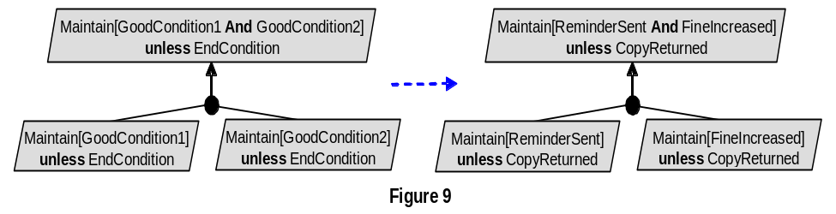  Figure 9 [file: Figure-8.9.jpg] shows the __________________
a. | Unrealizability-driven refinement pattern.
b. | Unmonitorability-driven refinement pattern.
c. | Divide-and-conquer refinement pattern.
d. | Milestone-driven refinement pattern
e.
f.
ANS: | C
PTS: | 1
CHAPTER: | 8
MIX CHOICES: | YES

QN=46 | 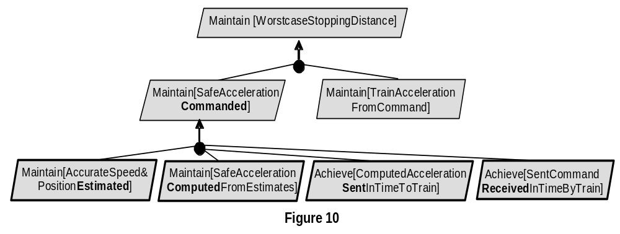  Figure 10 [file: Figure-8.10.jpg] shows the __________________
a. | Case-driven refinement pattern
b. | Guard-introduction pattern
c. | Divide-and-conquer pattern
d. | Milestone-driven refinement pattern
e.
f.
ANS: | D
PTS: | 1
CHAPTER: | 8
MIX CHOICES: | YES

QN=47 | An AND-refinement states that the parent goal can be satisfied by satisfying ______sub-goals in the refinement.
a. | one of
b. | all
c. | some of
d.
e.
f.
ANS: | B
PTS: | 1
CHAPTER: | 8
MIX CHOICES: | YES

QN=48 | The goals G1, G2, …, Gn are divergent in a domain Dom if we can find a feasible boundary condition B under which the goals cannot satisfied the arguments. Which of the following reflects the above definition?
a. | {G1, G2, …, Gn, B, Dom} |= true
b. | {G1, G2, …, Gn, B, Dom} |= false
c. | {G1, G2, …, Gn, B, Dom} |= G
d. | {G1, G2, …, Gn, B, Dom} satisfied G
e.
f.
ANS: | B
PTS: | 1
CHAPTER: | 8
MIX CHOICES: | YES

QN=49 | Which refinement pattern is applied for the goal refinement in the figure 8-12 [file: Figure-8.12.GIF]?  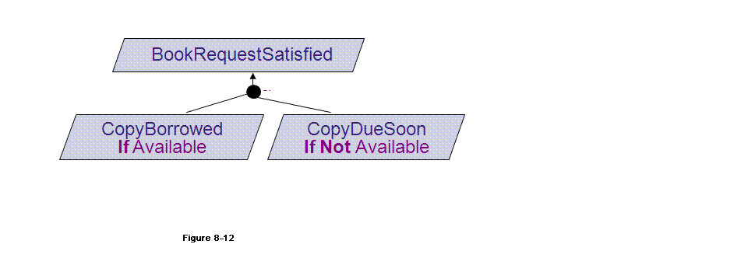  [CopyBorrowedIfAvailable]  Def A book has a copy available for the requesting borrower  [CopyDueSoonIfNotAvailable]  Def A book without any copy available for loan shall have a copy available within 15 days for the requesting borrower
a. | Case-driven refinement pattern
b. | Guard-introduction pattern
c. | Divide-and-conquer pattern
d. | Milestone-driven refinement pattern
e.
f.
ANS: | a
PTS: | 1
CHAPTER: | 8
MIX CHOICES: | YES

QN=50 | When doing goals refinement, we refine goals until___________
a. | the sub-goals assignable to single agents
b. | the sub-goals assignable to a multi-agents
c. | the sub-goals to be easier assessment feasibility
d. | the sub-goals to be easier implementation
e.
f.
ANS: | A
PTS: | 1
CHAPTER: | 8
MIX CHOICES: | YES

QN=51 | 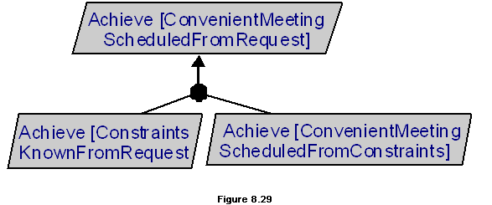  In the figure 8.29 [file: Figure-8.29.gif], the goal refinement pattern is _____
a. | Refinement towards goal realizability
b. | Refinement by milestones
c. | Refinement by case
d. | Divide-and-Conquer
e.
f.
ANS: | b
PTS: | 1
CHAPTER: | 8
MIX CHOICES: | YES

QN=52 | 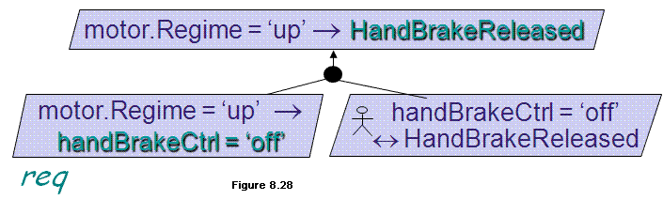  In the figure 8.28 [file: Figure-8.28.gif], the goal refinement pattern is _____
a. | Refinement towards goal realizability
b. | Refinement by milestones
c. | Refinement by case
d. | Divide-and-Conquer
e.
f.
ANS: | a
PTS: | 1
CHAPTER: | 8
MIX CHOICES: | YES

